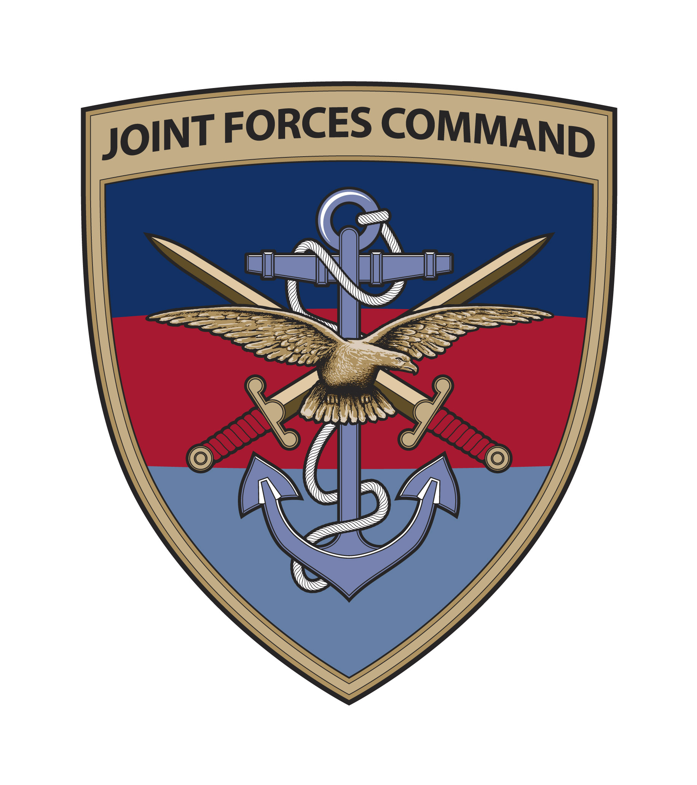
Dental Centre RAF Leeming
Northallerton,
North Yorkshire,
DL7 9NJ

Telephone: 01677 457565
Email : DDSNE-Leeorthodontist@mod.uk
All members
British Orthodontic Society
12 Bridewell Place
London
EC4V 6AP
Date: 28 February 2014

Medical entry standard to the Army, Royal Navy and Royal Air Force

I write to appraise all BOS members about recent changes to the Medical Entry Standard to the Army, Royal Navy and Royal Air Force. Recruits undergo a very intense period of initial military induction followed by more lengthy phase 2 role specific training. During both phases, there is no flexibility or spare capacity in the program, to enable recruits to attend regular medical or dental appointments. Experience has shown that when candidates undergoing orthodontic treatment are accepted, they commonly spend lengthy periods without professional supervision during which permanent irreversible harm can occur.

Following due consideration by the Medical Employment Standard Working Group, taking into account both the needs of the Service and the best interests of the recruits, the section of the Joint Service Publication 950 as it relates to orthodontic treatment (Leaflet 6-7-4 Annex M:Dental) has recently been amended.

Potential candidates applying for either full or reserve service, who are undergoing orthodontic treatment with fixed or removable active appliances, will normally be graded P8 (unsuitable for entry) but may re-apply on successful completion of their orthodontic treatment. Retainers, either bonded or removable, must continue to be worn and will not preclude entry to the military. The removal of active appliances simply to facilitate service entry is not to be undertaken or advised, as candidates presenting having had appliances removed prematurely will also be graded P8.

Candidates applying to either the Army Foundation College Harrogate or the Defence 6th Form College will be considered on a case by case basis and may be accepted if treatment can be managed within the constraints of the training timetable that the trainees are required to meet. Individuals applying to either of these locations must make arrangements to continue orthodontic treatment with their civilian orthodontist for the duration of their studies.

Whilst the final decision on medical suitability for a candidate rests with each single Service’s Occupational Physician responsible for entry approvals, it is hoped that this notification of policy will clarify the situation for all members of the BOS. Whilst I am more than happy to discus further if required, I am unable to comment on any individual cases which must go through due process.

Bruce Nelson
Group Captain
Defence Dental Services Adviser Orthodontics

